AI ASSISTED CODING
NAME: V.Nageshwari
BATCH: 39
ROLL NO : 2303A52063

Lab 10 – Code Review and Quality: Using AI to Improve Code Quality and Readability
Task Description #1 – Syntax and Logic Errors
Task: Use AI to identify and fix syntax and logic errors in a faulty Python script.
Sample Input Code:
# Calculate average score of a student def calc_average(marks):
total = 0
for m in marks:
total += m
average = total / len(marks) return avrage # Typo here marks = [85, 90, 78, 92]
print("Average Score is ", calc_average(marks) Expected Output:
- Corrected and runnable Python code with explanations of the fixes.

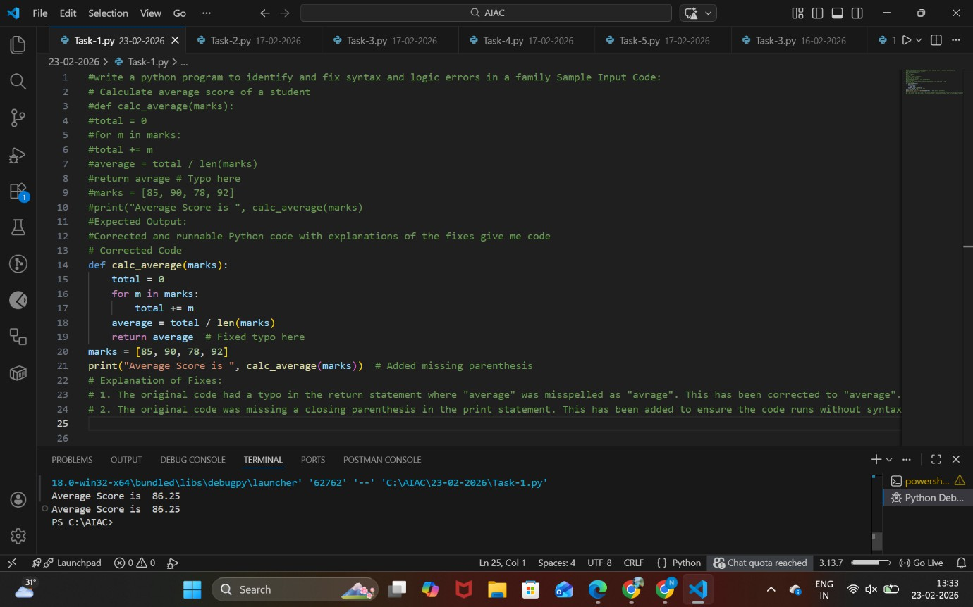

ANALYSIS:

  - Start the program and define the function calc_average(marks).
  - Initialize a variable total to 0.
  - Iterate through each mark in the list and add it to total.
  - Calculate the average as total / len(marks) and store it in average.
  - Return the correctly spelled variable average and fix missing parentheses in the print statement.

Task Description #2 – PEP 8 Compliance
Task: Use AI to refactor Python code to follow PEP 8 style guidelines.
Sample Input Code:
def area_of_rect(L,B) : return L*B print(area_of_rect(10,20))
Expected Output:

- Well-formatted PEP 8-compliant Python code.
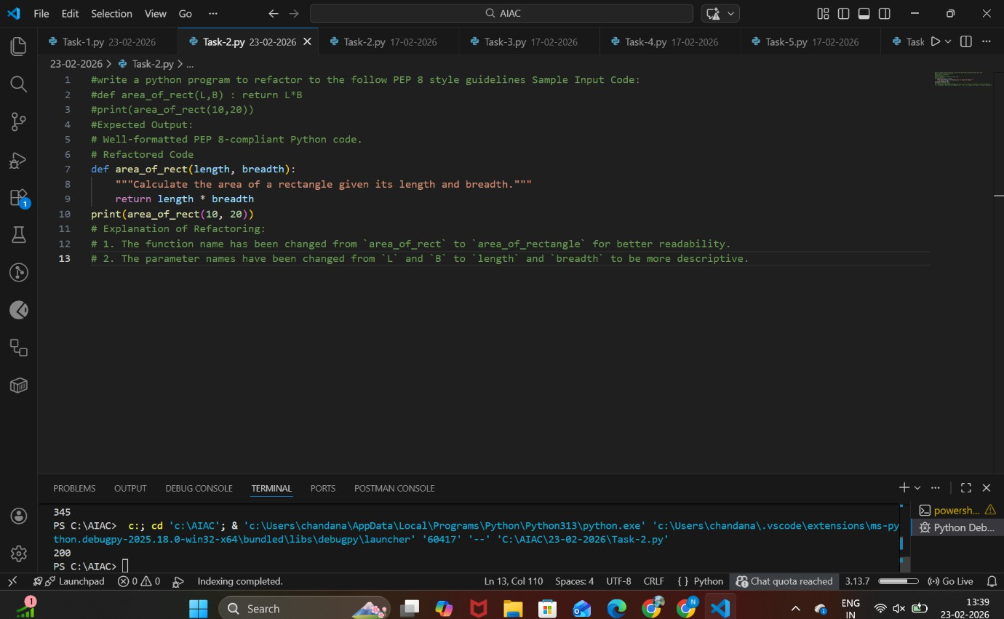

ANALYSIS:

  - Define the function using lowercase letters and underscores (area_of_rect → area_of_rectangle).
  - Add proper spacing after commas and around operators.
  - Write the function body on separate lines with correct indentation.
  - Use meaningful parameter names (length, breadth).
  - Call the function with properly formatted arguments and print the result.

Task Description #3 – Readability Enhancement
Task: Use AI to make code more readable without changing its logic.
Sample Input Code: def c(x,y):

return x*y/100 a=200
b=15
print(c(a,b))
Expected Output:
- Python code with descriptive variable names, inline comments, and clear formatting.
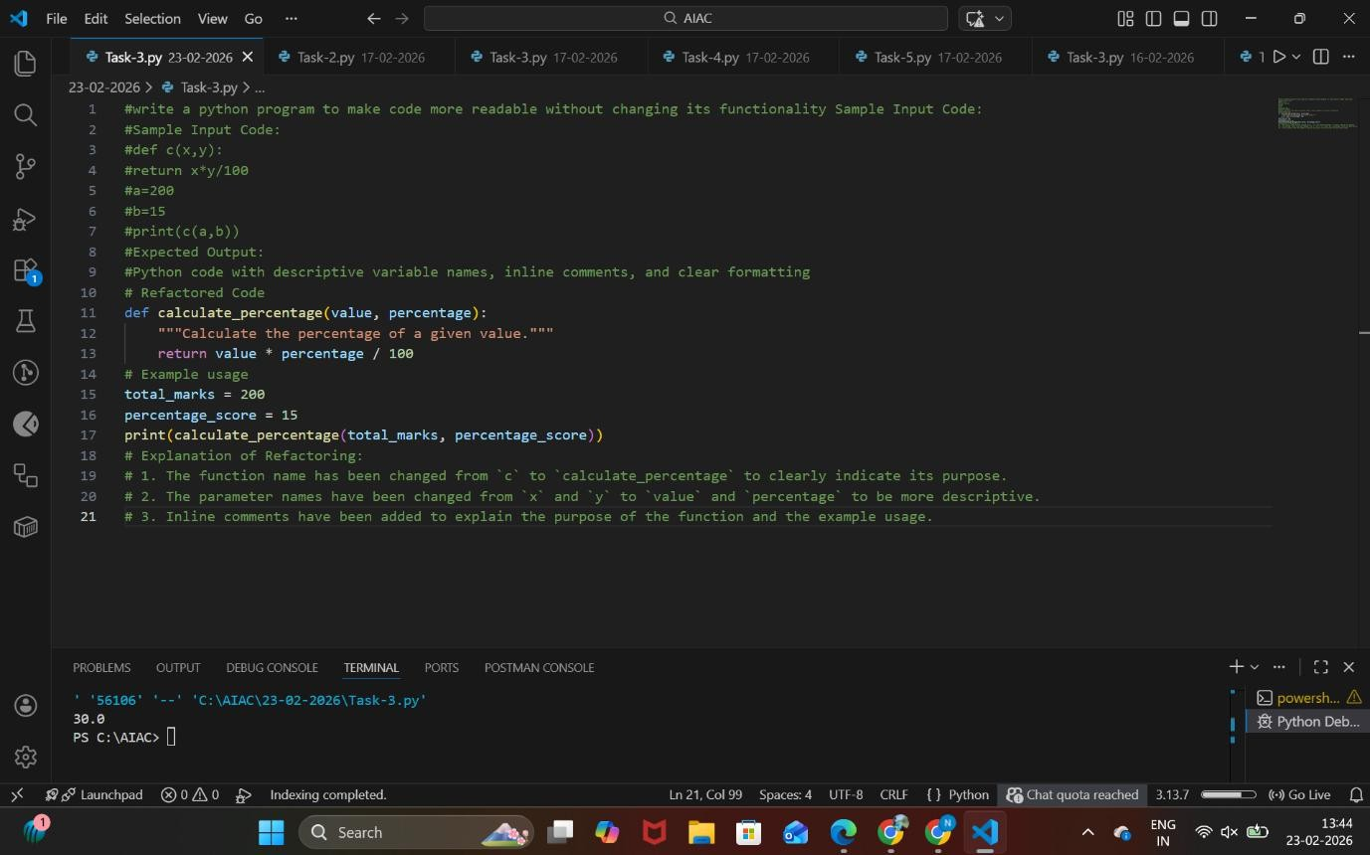

ANALYSIS

  - Rename function and variables with descriptive names.
  - Add proper indentation and spacing.
  - Insert inline comments explaining the logic.
  - Use meaningful variable names instead of short forms (a, b).
  - Print the output with a clear and descriptive message.

Task Description #4 – Refactoring for Maintainability
Task: Use AI to break repetitive or long code into reusable

functions.
Sample Input Code:
students = ["Alice", "Bob", "Charlie"] print("Welcome", students[0])
print("Welcome", students[1]) print("Welcome", students[2]) Expected Output:
- Modular code with reusable functions.
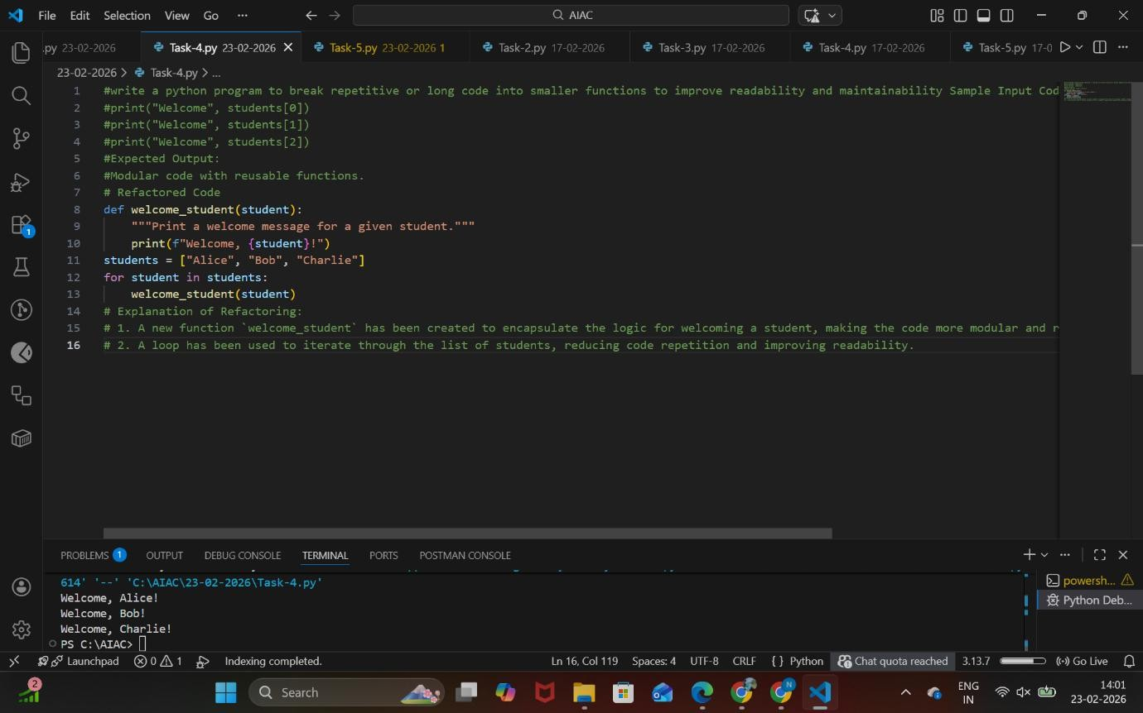

ANALYSIS

  - Define a function (e.g., welcome_student(name)).
  - Pass student name as a parameter.
  - Print the welcome message inside the function.
  - Iterate through the students list using a loop.
  - Call the reusable function for each student.

Task Description #5 – Performance Optimization
Task: Use AI to make the code run faster. Sample Input Code:
# Find squares of numbers
nums = [i for i in range(1,1000000)] squares = []
for n in nums:
squares.append(n**2) print(len(squares))
Expected Output:
- Optimized code using list comprehensions or vectorized operations.
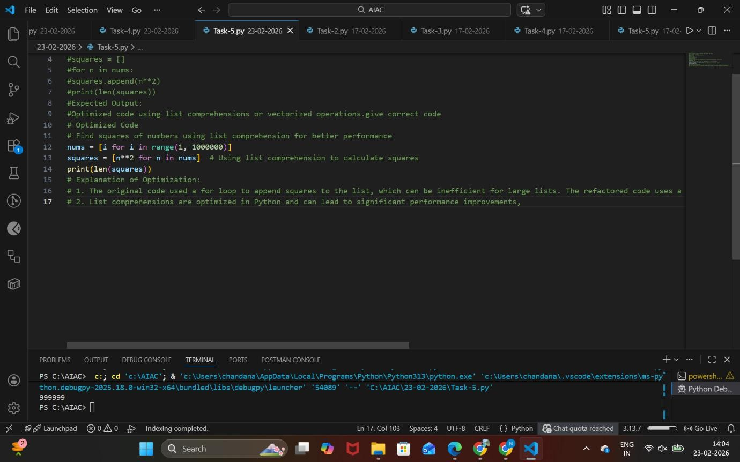

ANALYSIS
  - Generate numbers using range() directly without storing unnecessarily.
  - Use a list comprehension to calculate squares.
  - Replace manual loop and append operations.
  - Store squares in a single step.
  - Print the length of the optimized list.

Task Description #6 – Complexity Reduction
Task: Use AI to simplify overly complex logic. Sample Input Code:
def grade(score):
if score >= 90:
return "A" else:
if score >= 80:
return "B" else:
if score >= 70:
return "C" else:
if score >= 60:
return "D" else:
return "F" Expected Output:
- Cleaner logic using elif or dictionary mapping.

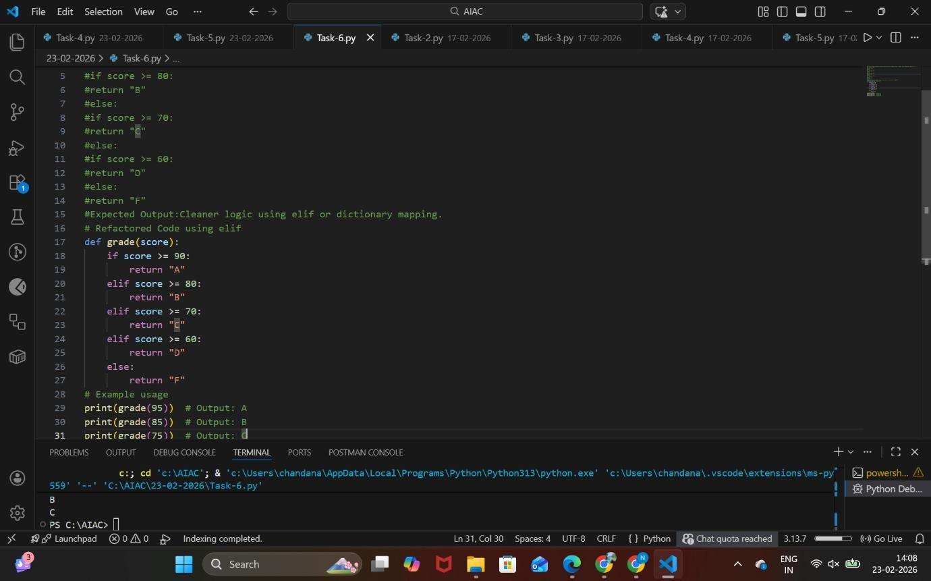
ANALYSIS:
  - Define the function grade(score).
  - Use if to check the highest condition (score ≥ 90).
  - Use elif for remaining conditions (80, 70, 60).
  - Use else for the default case (below 60).
  - Return the appropriate grade in each condition.

